Market Microstructure — Core Concepts
Order Books, Bid-Ask Spreads, Depth, Price Discovery, Order Flow, and the Real Cost of Trading
Why Trades Are Priced and Matched the Way They Are, One Order at a Time
A Level 2 module in the Quantitative Finance Curriculum — revisited at Level 5
Covers: order book · limit/market orders · maker/taker · bid-ask spread · queue position (awareness) · market depth · price discovery · order flow/trade flow · order-book imbalance (awareness) · adverse selection (awareness) · market impact/slippage · tick size · latency (awareness)

Table of Contents
How to Use This Guide
What You Need to Know Before Starting
Understand Before Proceeding
Why It Matters
How This Connects to the Rest of the Curriculum
Glossary of Recurring Terms
Part 1 — The Limit Order Book: Structure and Mechanics
1.1 What an Order Book Is and How It Is Organized
1.2 Limit Orders vs. Market Orders
1.3 Maker vs. Taker: Who Provides Liquidity, Who Takes It
1.4 Queue Position and Price-Time Priority (awareness)
Part 2 — Spread, Depth, and Price Discovery
2.1 The Bid-Ask Spread
2.2 Market Depth
2.3 Price Discovery
Part 3 — Order Flow and the Information Content of Trades
3.1 Order Flow and Trade Flow
3.2 Order-Book Imbalance (awareness)
3.3 Adverse Selection (awareness)
Part 4 — The Real Cost of Trading: Market Impact, Slippage, and Tick Size
4.1 Market Impact and Slippage
4.2 Tick Size
Part 5 — Latency (awareness)
5.1 Why Speed Matters in a Queue-Based System
Practical Exercise
Common Beginner Mistakes
Advanced Extensions
Professional Applications
Where to Go Next

How to Use This Guide
This document is a companion to Market Microstructure — Core Concepts, the module in the quantitative finance curriculum that sits directly beneath every backtest, execution algorithm, and market-making strategy you will ever build. It covers how trades are actually matched and priced at the level of individual orders — not the aggregate daily-close price series most self-taught quants start with, but the order book underneath it.
The module is self-contained: every concept is introduced from first principles, paired with a worked numerical example, and illustrated with a chart or diagram wherever a picture makes the idea land faster than prose. Read it start to finish if microstructure is new to you, or jump straight to the section you need — but do not skip Understand Before Proceeding below.

What You Need to Know Before Starting
- Financial Market Structure — what exchanges, ECNs, and dark pools are, and broadly how an order gets from a trader to a venue.
- Trading Mechanics — order types at a conceptual level (market vs. limit), and the idea that trades require a buyer and a seller to meet on price.
- Basic arithmetic with prices and sizes — nothing beyond percentages, weighted averages, and reading a table of numbers; no calculus or stochastic calculus is required at this level.

Understand Before Proceeding
Prerequisite gate — Do not attempt market-making or HFT strategies before this reaches Depth 3+. Everything in this module is deliberately at awareness depth for the harder topics (queue position, order-book imbalance, adverse selection, latency) — enough to reason correctly about why backtests fail and what a real fill actually costs, but not enough to safely design or operate a live market-making or high-frequency system. That requires the Depth 3+ treatment of this same material, with inventory risk, adverse-selection models, and latency engineering treated quantitatively rather than conceptually.

Why It Matters
Market microstructure is the missing layer in most self-taught quant educations, and the direct cause of backtests that look great on daily closing prices but fail to survive real transaction costs. A strategy that is profitable against a frictionless price series can be unprofitable the moment it has to actually cross a spread, walk through a thin book, and wait in a queue behind other orders at the same price. Every one of those frictions is a microstructure effect, and none of them show up in a close-to-close backtest unless you deliberately model them.
The practical stakes are large. A strategy earning 3 basis points of theoretical edge per trade is worthless — indeed, loss-making — if the round-trip cost of actually executing it (spread plus market impact plus, for a stale limit order, adverse selection) is 5 basis points. You cannot know which side of that line you are on without understanding the order book.

How This Connects to the Rest of the Curriculum
- Research — Realistic transaction-cost and slippage modelling in a backtest depends on understanding microstructure, not just applying a flat cost assumption; a 5-bps-per-trade haircut is a guess, a depth-aware impact model is an estimate.
- Development — Order-book data structures (price-level maps, FIFO queues per level) and matching-engine logic are core to any execution-simulation infrastructure — you cannot build a realistic simulator without them.
- Trading — Every real trade interacts with the order book; understanding it is what separates 'testing an idea on daily close prices' from actually trading it, where fills, queue position, and adverse selection are real and unavoidable.

Glossary of Recurring Terms
Order book — The live, continuously updated list of all outstanding limit orders for an instrument, organized by price and, within each price, by time of arrival.
Limit order — An order to buy or sell at a specified price or better; it rests in the book and adds liquidity until it trades or is cancelled.
Market order — An order to buy or sell immediately at the best currently available price(s); it removes liquidity from the book.
Maker — A participant whose order rests in the book and is later executed against by an incoming order — the liquidity provider in a given trade.
Taker — A participant whose order executes immediately against resting liquidity — the liquidity remover in a given trade.
Bid-ask spread — The gap between the best (highest) resting buy price and the best (lowest) resting sell price; the minimum round-trip cost of trading immediately.
Queue position — An order's place in the first-in-first-out line of orders resting at the same price level; earlier arrival means earlier execution.
Market depth — The cumulative size resting at and beyond the best bid/ask, describing how much can be traded before price must move to find more liquidity.
Price discovery — The process by which new information gets incorporated into the traded price through the arrival and matching of orders.
Order flow — The sequence of incoming orders (limit and market) arriving at the book over time.
Trade flow — The sequence of executed trades — order flow's realized subset — each carrying a price, size, and side.
Order-book imbalance — A measure of the asymmetry between resting bid and ask size, often used as a short-horizon predictor of price direction.
Adverse selection — The risk a liquidity provider bears that a counterparty is better informed, so that resting orders are disproportionately filled just before the price moves against them.
Market impact — The amount by which a trade's own execution moves the price against the trader, as a function of its size relative to available liquidity.
Slippage — The difference between the price expected at the time a trading decision is made and the price actually achieved on execution.
Tick size — The minimum allowable increment between valid prices for an instrument; all quotes and trades must fall on this grid.
Latency — The time delay between an event occurring (e.g., a quote update) and a given participant being able to observe and react to it.

Part 1 — The Limit Order Book: Structure and Mechanics
Every liquid, order-driven market — equities, futures, most FX, and virtually all crypto exchanges — is organized around a limit order book: a live ledger of every outstanding order to buy or sell, sorted by price and, within each price, by the time the order arrived. This part covers what the book actually looks like, the two fundamental order types that interact with it, and the maker/taker relationship that falls out of that interaction.

1.1 What an Order Book Is and How It Is Organized
The book has two sides. The bid side lists resting buy orders, sorted from the highest (best) price down to the lowest. The ask side (also called the offer side) lists resting sell orders, sorted from the lowest (best) price up to the highest. The highest bid and lowest ask together are called the top of book, or the touch; everything below that on both sides is collectively the book's depth.
Within a single price level, orders queue in first-in-first-out (FIFO) order under the most common price-time priority matching rule: better prices always trade first, and among orders at the identical price, the one that arrived first executes first. (Some venues use variants — pro-rata allocation is common in certain futures markets — but price-time priority is the default you should assume unless told otherwise.)
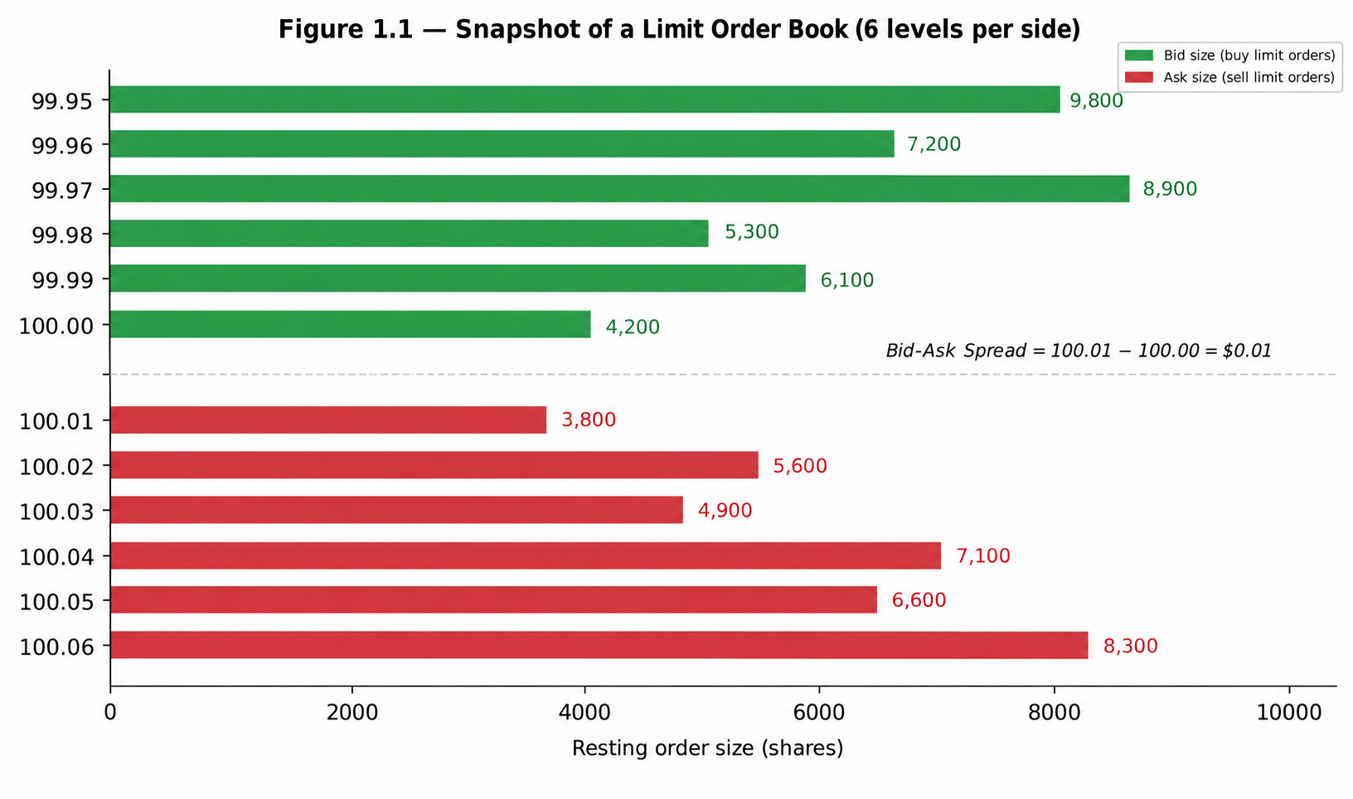
Figure 1.1 — A snapshot of a limit order book with six price levels resting on each side. The best bid (100.00) and best ask (100.01) form the touch; everything further away is depth.
Concretely, in Figure 1.1: 4,200 shares are willing to buy at 100.00 (the best bid), and 3,800 shares are willing to sell at 100.01 (the best ask). A trader who simply wants to buy right now can only be guaranteed the first 3,800 shares at 100.01 — the 3,801st share, if the order is larger, must trade at 100.02 or worse, because that is as far as the resting liquidity at 100.01 goes. This is the seed of market impact, covered fully in Part 4.
Worked example — A trader wants to know the best bid and depth at the top three levels. From the book above: best bid = 100.00 (4,200 shares); next level down = 99.99 (6,100 shares); next = 99.98 (5,300 shares). Total size available to sell into the top three bid levels without moving past 99.98 is 4,200 + 6,100 + 5,300 = 15,600 shares.

1.2 Limit Orders vs. Market Orders
A limit order specifies a price: 'buy up to 500 shares at 100.00 or better' or 'sell up to 500 shares at 100.05 or better.' If it cannot trade immediately at that price, it rests in the book, adding to depth, and waits. Because it commits to waiting, a limit order controls price but not certainty or speed of execution — it might never fill if the market moves away.
A market order specifies only a size, not a price: 'buy 500 shares, whatever it costs.' It walks the book from the best available price outward until fully filled. Because it demands immediate execution, a market order controls speed and certainty but not price — the trader accepts whatever the book currently offers, including any market impact from its own size.
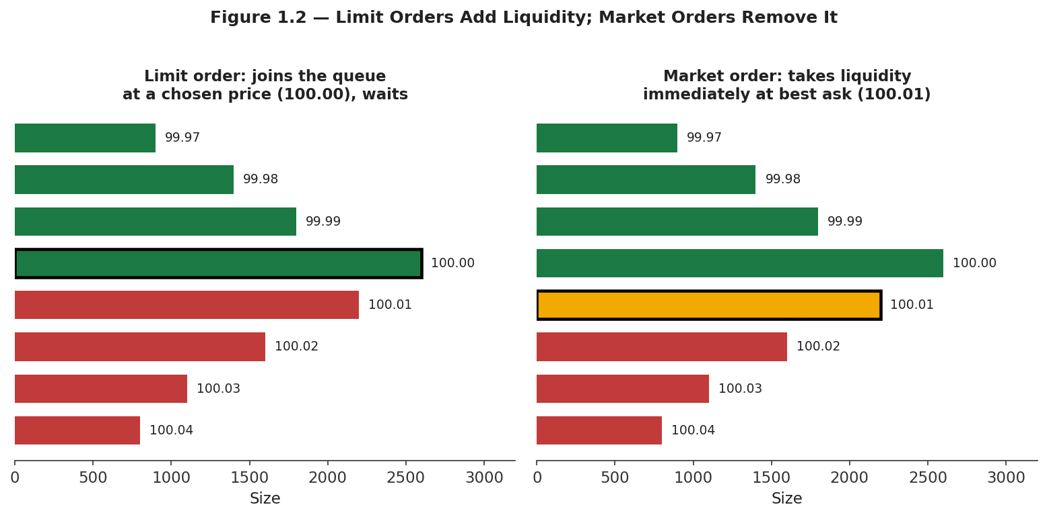
Figure 1.2 — A limit order (left) joins the queue at a chosen price and waits; a market order (right) trades immediately against the best available resting price.
Marketable limit order = a limit order priced aggressively enough to cross the spread and execute immediately, behaving like a market order but with a worst-price guarantee
This third, hybrid category matters in practice: most 'market orders' sent by sophisticated participants are actually marketable limit orders, because a pure market order carries no protection at all against an unexpectedly bad fill price in a fast-moving or thin book.

1.3 Maker vs. Taker: Who Provides Liquidity, Who Takes It
Every trade has exactly one maker — the side whose order was already resting in the book — and one taker — the side whose incoming order matched against it. A resting limit order that gets filled is always the maker in that trade; an incoming market order (or a marketable limit order) is always the taker. Makers add liquidity to the book; takers remove it.
Most electronic venues charge for this asymmetry directly through a maker-taker fee schedule: makers are paid a small rebate for supplying liquidity, and takers pay a slightly larger fee for consuming it, with the venue keeping the difference. This is not a footnote — it is a first-order input to any strategy that trades frequently.
# Illustrative US-equity-style maker/taker economics on 10,000 shares
shares = 10_000
maker_rebate_per_share = 0.0020 # e.g., $0.0020/share paid TO the maker
taker_fee_per_share = 0.0030 # e.g., $0.0030/share paid BY the taker

maker_pnl_from_fees = shares * maker_rebate_per_share # +$20.00
taker_pnl_from_fees = -shares * taker_fee_per_share # -$30.00
# Over thousands of trades a day, this difference alone can decide
# whether a high-frequency strategy is profitable.
Common mistake — Assuming a strategy is 'the same' whether it crosses the spread (taking) or posts and waits (making). Two strategies with identical directional views can have opposite sign P&L once spread cost, fees/rebates, and fill probability are accounted for — a passive (maker) version of a strategy earns the spread and a rebate but risks not filling at all; an aggressive (taker) version fills with certainty but pays the spread and a fee.

1.4 Queue Position and Price-Time Priority (awareness)
This subsection is awareness-level: enough to reason correctly about why two seemingly identical limit orders at the same price can have very different fill outcomes, not a full treatment of queue-position modelling, which belongs to Depth 3+.
Because orders at the same price fill in FIFO arrival order, an order's queue position — how many shares are resting ahead of it at that price — determines both whether it fills and, if trading fast-moving, informed markets, what kind of fill it gets when it does. A new limit order placed at an already-crowded price level sits behind everyone who arrived earlier; all of that size must trade away first.
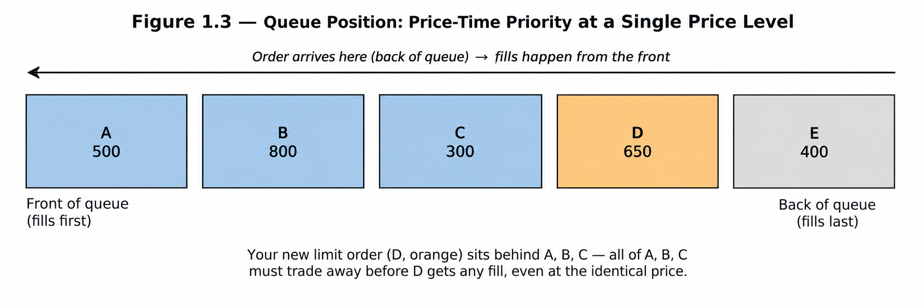
Figure 1.3 — Price-time priority within a single price level: order D, though placed at the identical price as A, B, and C, must wait for all of them to trade away first.
Queue position matters most acutely for market-making and passive execution strategies, for two related reasons covered more fully at Depth 3+: (1) a favorable, front-of-queue position gets filled more often and with a better mix of counterparties, since it captures liquidity-taking flow before the market has had time to react; and (2) a poor, back-of-queue position tends to be filled disproportionately by informed flow that has already outlasted everyone ahead of it in the queue — an early flavor of the adverse-selection problem in Section 3.3.

Part 2 — Spread, Depth, and Price Discovery
Zooming out from individual orders, this part covers the three aggregate properties of the book that matter most for anyone consuming a price series rather than building a matching engine: how wide the spread is, how much size sits behind it, and how the whole apparatus arrives at a price that reflects available information.

2.1 The Bid-Ask Spread
The quoted (or 'inside') spread is simply the best ask minus the best bid — the minimum cost, in price terms, of buying and immediately selling (or vice versa) at the touch:
Quoted spread = Best Ask − Best Bid
It is often expressed relative to the mid-price (the average of best bid and best ask) in basis points, to make comparisons across instruments and price levels meaningful:
Mid-price = (Best Bid + Best Ask) / 2 Relative spread (bps) = 10,000 × (Best Ask − Best Bid) / Mid-price
Worked example — Best bid = 100.00, best ask = 100.01. Quoted spread = $0.01. Mid-price = 100.005. Relative spread = 10,000 × 0.01 / 100.005 ≈ 1.0 bps. For a $10 stock with the same one-cent spread, relative spread = 10,000 × 0.01 / 10.00 = 10 bps — ten times as expensive to cross, even though the dollar spread looks identical.
A second, more realistic measure is the effective spread, which uses the price an order actually executed at rather than the quoted best price, and so captures any market impact beyond the touch:
Effective spread = 2 × |Execution price − Mid-price at order arrival|
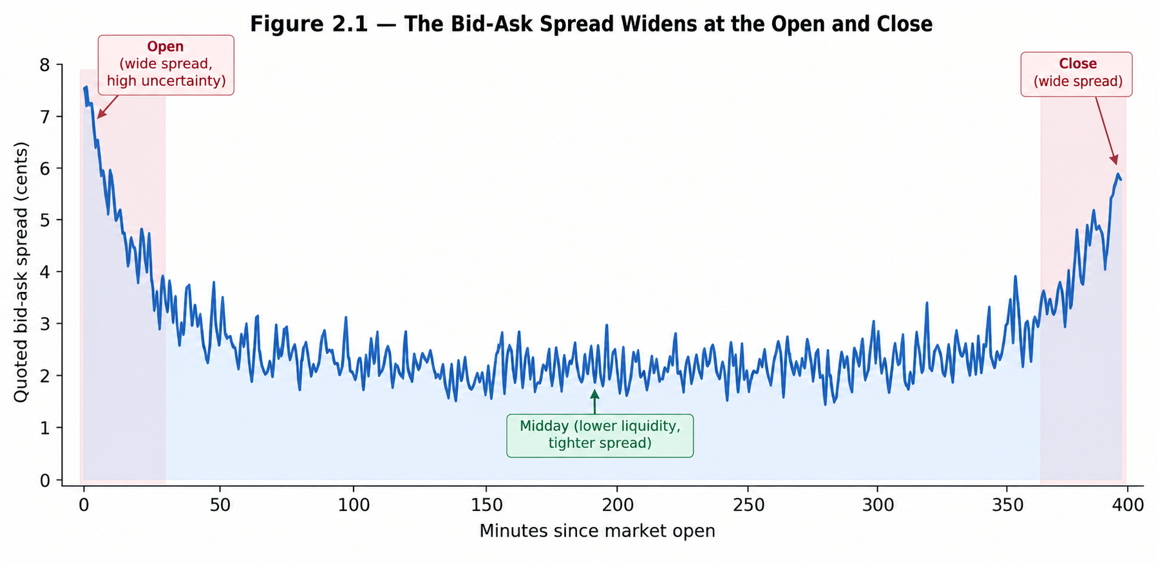
Figure 2.1 — Quoted spreads are systematically wider at the open and close, when uncertainty about fair value is highest and fewer market makers are actively quoting, and tightest mid-session when liquidity is deepest.
Spreads compensate liquidity providers for three things: order-processing cost (the operational cost of running a market-making operation), inventory risk (the risk of holding an unwanted position while waiting to offload it), and adverse selection (Section 3.3) — the risk of trading against better-informed counterparties. All three widen the spread; none of them is a broker fee, and a backtest that ignores the spread is implicitly assuming a liquidity provider will always trade with you for free.

2.2 Market Depth
The quoted spread only describes the cost of trading a small size at the very top of the book. Market depth — the cumulative size available at and beyond the best price on each side — describes what happens to larger orders, and is usually visualized as a cumulative step function of price.
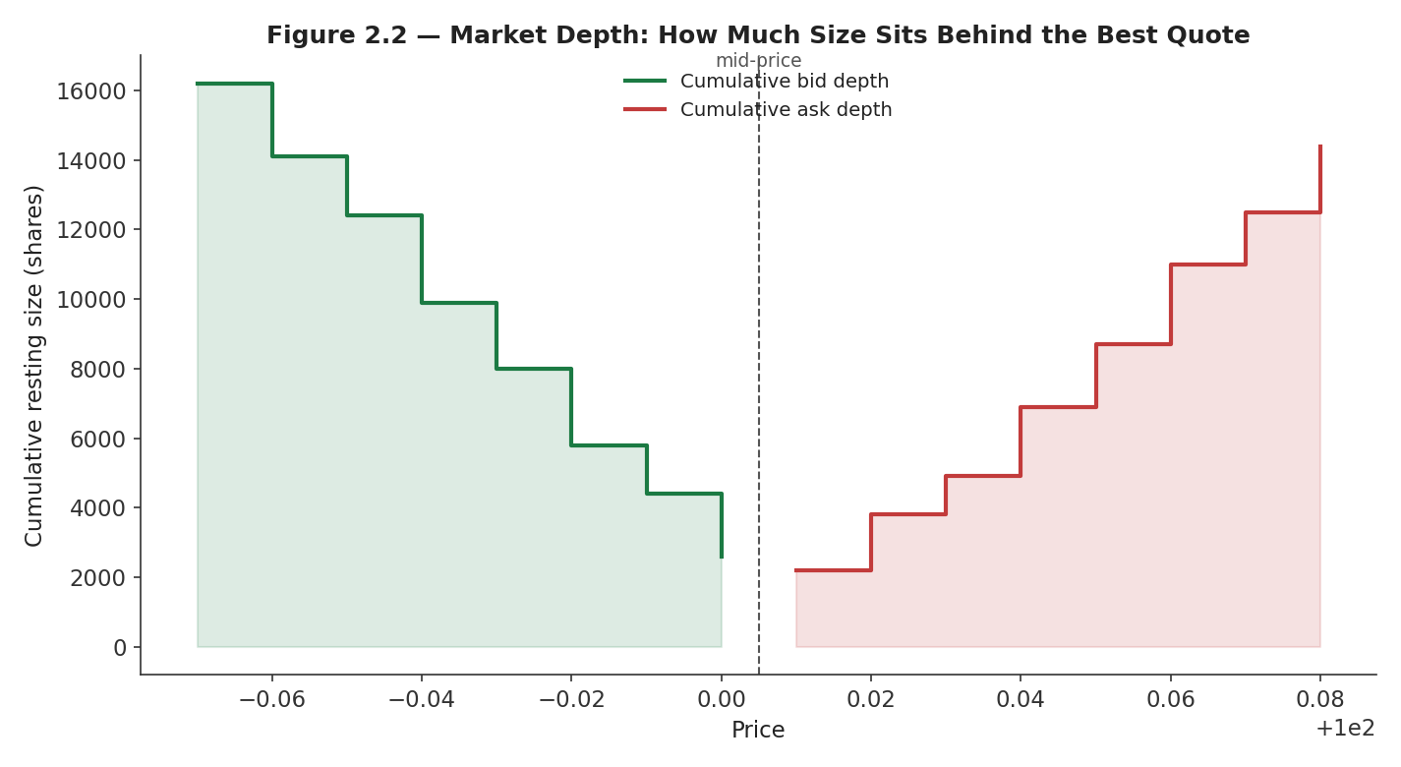
Figure 2.2 — Cumulative market depth on both sides of the book. A trade small enough to stay within the first level pays close to the quoted spread; a trade large enough to reach the fourth or fifth level pays materially more.
Depth is not static. It is thinnest exactly when it is needed most — around news events, at the open and close, and during fast markets — because market makers pull resting orders when the risk of being adversely selected rises. A backtest that assumes constant, quoted-size-only depth will systematically overstate how much size can be traded cheaply, and will understate cost precisely during the volatile periods that often matter most to a strategy's overall P&L.
Common mistake — Assuming infinite liquidity at the quoted price for any order size. In Figure 2.2, only the first 2,600 shares can trade at the best bid (100.00); the next 1,800 must trade at 99.99, and so on. A backtest that lets a 20,000-share order fill entirely at the last-observed best bid is fabricating liquidity that did not exist.

2.3 Price Discovery
Price discovery is the mechanism, not a metaphor: it is the literal process by which new information — an earnings surprise, a macro data release, a large informed trade — gets absorbed into the traded price through the arrival of new orders and the cancellation of stale ones. Before the book has 'seen' new information, quotes reflect the old fair value; as informed order flow arrives, market makers update their own beliefs and re-quote, and the touch moves toward the new fundamental value.
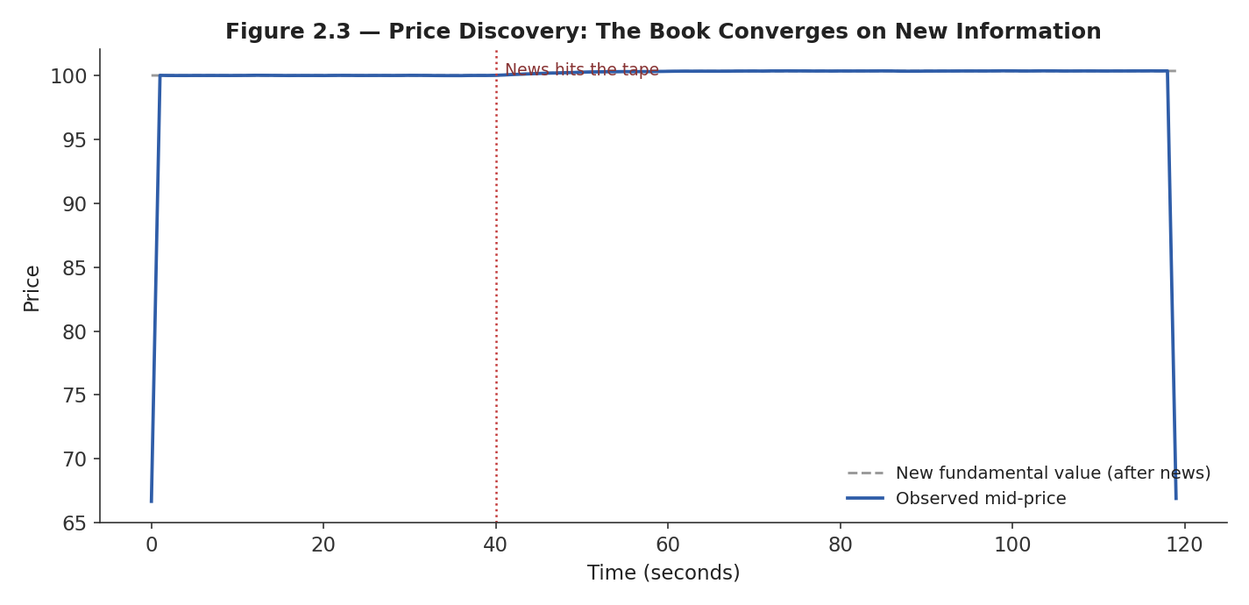
Figure 2.3 — After news hits the tape, the observed mid-price does not jump instantaneously to the new fundamental value; it converges over a short window as informed order flow arrives and market makers update their quotes.
This convergence is rarely instantaneous, and the speed and cleanliness of it is itself a measure of market quality: a liquid, well-arbitraged market converges quickly and with little overshoot; a thin or fragmented one can overshoot, oscillate, or converge only slowly as information diffuses across venues. Every price series you have ever back-tested against is the output of this process — not a clean, exogenously given signal, but the residue of thousands of individual order-matching events.

Part 3 — Order Flow and the Information Content of Trades
If Parts 1 and 2 describe the static structure of the book, Part 3 describes its dynamics: the stream of incoming orders and executed trades, and what that stream reveals — sometimes predictively — about where the price is headed next.

3.1 Order Flow and Trade Flow
Order flow is the full sequence of incoming orders — limit and market, on both sides — arriving at the book over time. Trade flow is the realized subset of that: only the orders (or portions of orders) that actually executed, each carrying a price, a size, and a trade sign (+1 for a buyer-initiated trade, −1 for a seller-initiated trade, conventionally assigned to whichever side's order was the taker).
Signed trade sign = +1 if the taker was a buyer (hit the ask), −1 if the taker was a seller (hit the bid)
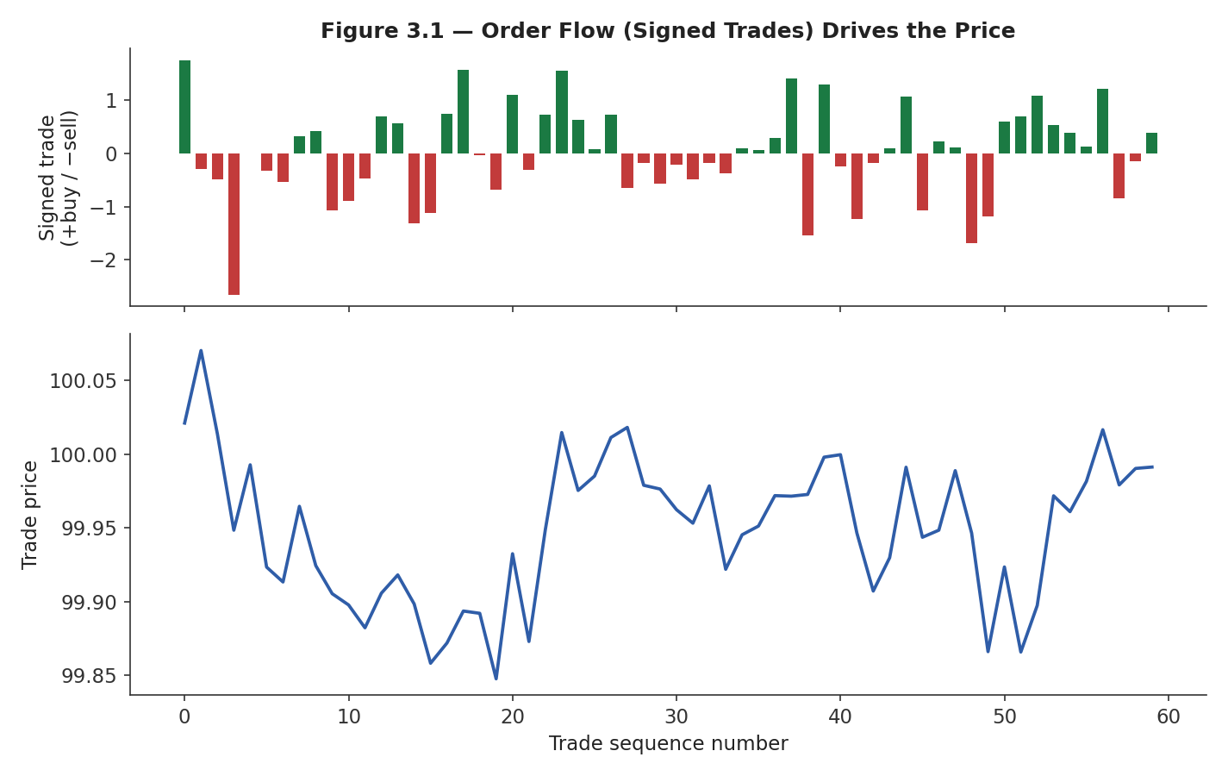
Figure 3.1 — Cumulative signed order flow (top) and the resulting trade price path (bottom). Persistent buy-side flow (green) pushes price up; persistent sell-side flow (red) pushes it down.
This is the empirical basis for a large branch of microstructure research and short-horizon trading: because trade flow both reflects and causes price movement, its recent history carries predictive information about the very next few trades — an effect with no analogue in a daily-bar price series, where all of this intraday structure has already been aggregated away.

3.2 Order-Book Imbalance (awareness)
Awareness-level: understand what the signal is and why it works conceptually, not how to build a production imbalance-based trading signal, which belongs to Depth 3+.
Order-book imbalance (OBI) measures the asymmetry between resting bid and ask size, typically at the top one or few levels:
OBI = (Bid depth − Ask depth) / (Bid depth + Ask depth), bounded between −1 and +1
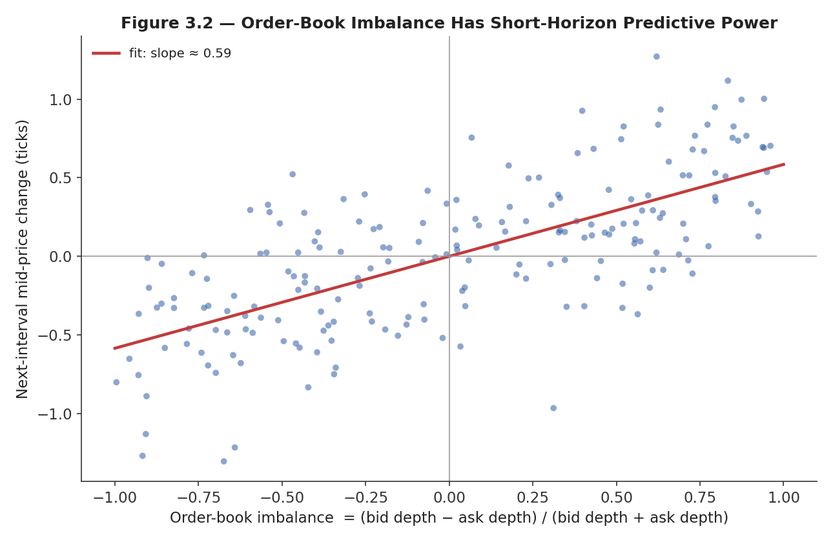
Figure 3.2 — Order-book imbalance against the price move in the following short interval. A positive imbalance (more resting buy size than sell size) is associated, on average, with a subsequent price increase.
The intuition: a book with far more resting buy size than sell size suggests more buying interest is queued up relative to selling interest, so the next aggressive order is statistically more likely to need to walk up through the (thinner) ask side than down through the (thicker) bid side, nudging price upward. The relationship in Figure 3.2 is real but noisy and extremely short-horizon — this is a microseconds-to-seconds signal, not an investment thesis, and it decays quickly as other participants react to the same imbalance.

3.3 Adverse Selection (awareness)
Awareness-level: understand the mechanism and why it forces spreads wider, not how to build a full information-based market-making model, which belongs to Depth 3+.
Adverse selection is the risk a liquidity provider bears every time a resting order gets filled: the counterparty who chose to trade against it might simply be a liquidity-seeking, uninformed participant — or might be trading precisely because they possess information the maker does not yet have. A classic result in the Glosten-Milgrom family of models formalizes this: a market maker who cannot tell informed from uninformed counterparties apart must set a spread wide enough that the losses suffered trading against informed flow are covered by the profits earned trading against uninformed flow.
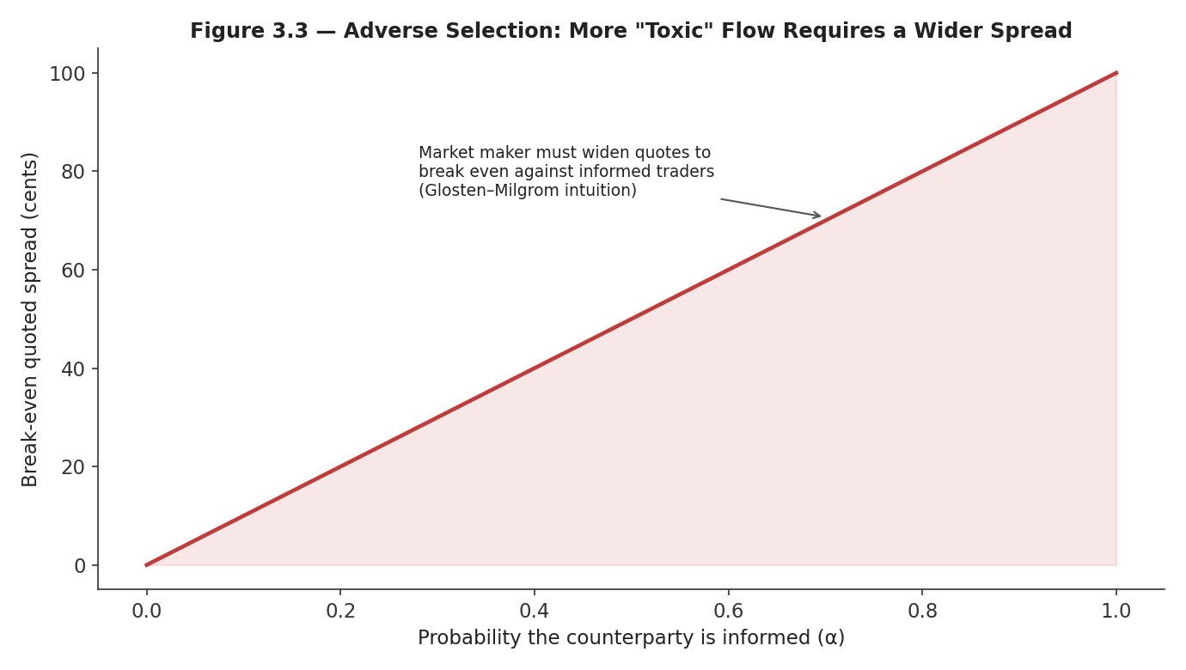
Figure 3.3 — As the proportion of informed ("toxic") counterparties rises, the break-even quoted spread a market maker must charge rises with it, in the simplest version of this logic.
This is why spreads widen mechanically around scheduled news events (earnings, central bank announcements): market makers rationally expect a higher proportion of informed flow in that window and reprice the risk of being adversely selected before it materializes, rather than after. The same logic is why a resting limit order that sits in the book for a long time without filling, and then suddenly fills right before an adverse price move, is not bad luck — it is adverse selection doing exactly what the theory predicts.

Part 4 — The Real Cost of Trading: Market Impact, Slippage, and Tick Size
This part connects the mechanics of Parts 1–3 directly to what shows up (or fails to show up) in a strategy's realized P&L: the gap between a theoretical price and an actual fill.

4.1 Market Impact and Slippage
Slippage is simply the difference between the price a trader expected when deciding to trade (the arrival price, usually the mid-price at that moment) and the price actually achieved. Market impact is the specific component of slippage caused by the trade's own size interacting with finite depth — the phenomenon introduced informally in Section 1.1, made precise here.
Slippage = Execution price − Arrival mid-price (for a buy; sign-flipped for a sell)
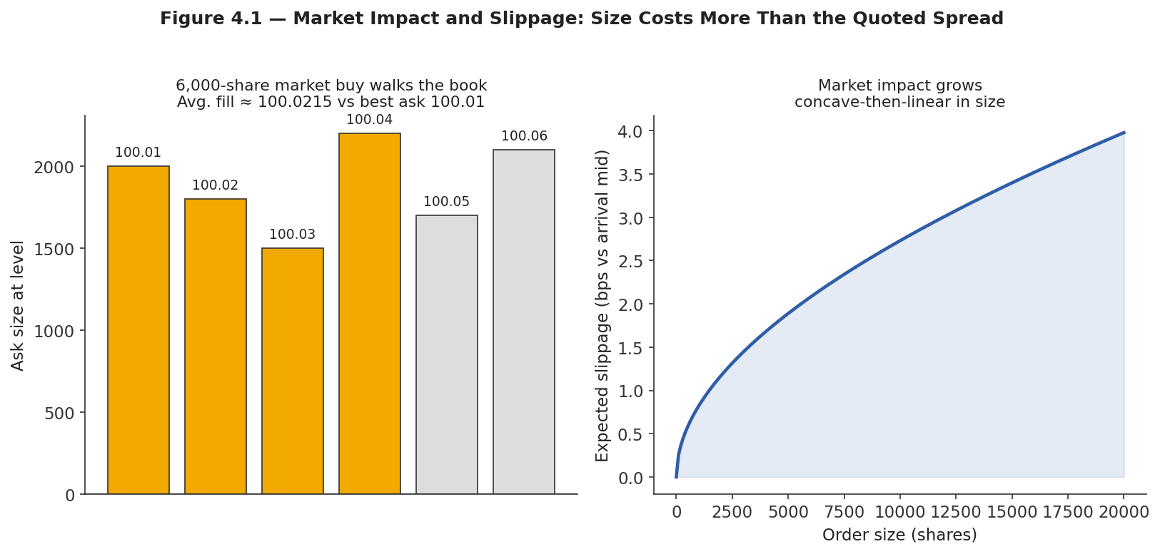
Figure 4.1 — Left: a 6,000-share market buy exhausts several price levels ("walks the book"), so its average fill price is worse than the best ask alone would suggest. Right: expected slippage as a function of order size follows a concave-then-linear shape — the widely used "square-root law" of market impact.
A common empirical approximation, the square-root law of market impact, states that expected impact scales roughly with the square root of order size relative to typical traded volume, not linearly:
Expected impact (bps) ≈ c × σ × √(Order size / Average daily volume)
where σ is the asset's volatility and c is an empirically fitted constant. The practical implication is important and non-obvious: doubling an order's size less than doubles its expected impact, but a single large order still costs substantially more per share, on average, than the same total size split into smaller pieces over time — which is precisely why execution algorithms (VWAP, TWAP, implementation shortfall) exist at all.
# Illustrative average fill price when a market order walks the book
levels = [(100.01, 2000), (100.02, 1800), (100.03, 1500),
(100.04, 2200), (100.05, 1700), (100.06, 2100)]
order_size = 6000

remaining, cost, filled = order_size, 0.0, 0
for price, size in levels:
take = min(size, remaining)
cost += take * price
filled += take
remaining -= take
if remaining <= 0:
break

avg_fill_price = cost / filled # ~100.0215, vs best ask 100.01
slippage_bps = 10_000 * (avg_fill_price - 100.01) / 100.01 # ~1.05 bps
Common mistake — Backtesting only against closing prices with no slippage or spread cost assumption. A strategy that trades daily at the close, sized as if it could transact its full order at the single printed closing price, has implicitly assumed zero spread and zero market impact — an assumption that is never true and least true for exactly the large, urgent orders a profitable strategy tends to generate.

4.2 Tick Size
Tick size is the minimum allowed increment between valid prices for an instrument — $0.01 for most US equities above $1, a fraction of a cent for some ETFs, a specified number of points for futures contracts. Every resting order, every quote, and every trade must land on this discrete grid; there is no such thing as a price of 100.014 if the tick size is one cent.
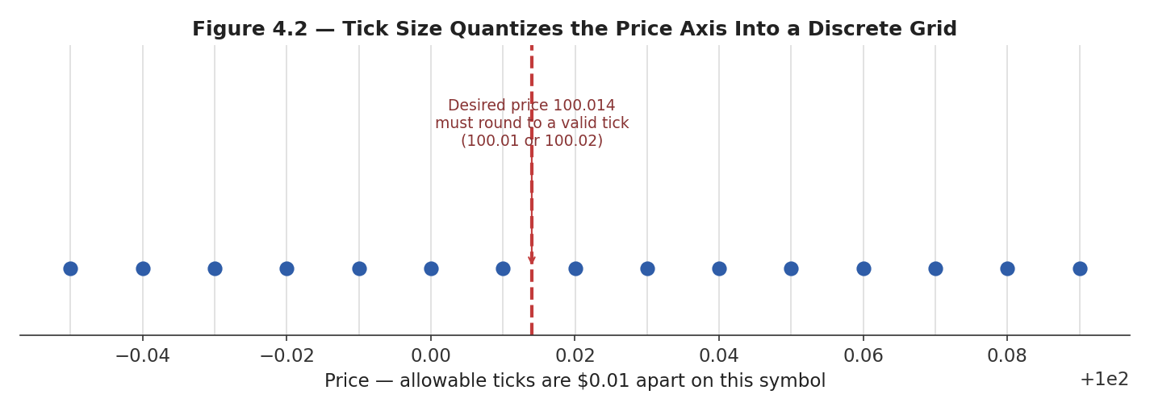
Figure 4.2 — Tick size quantizes the continuous price axis into a discrete grid; a desired price that does not fall on a valid tick must round to the nearest one.
Tick size interacts with almost everything covered so far. A relatively large tick size, relative to the instrument's price and typical trade size, imposes an artificial minimum spread — a market maker cannot quote a spread narrower than one tick even if competitive pressure would otherwise push it there — which in turn concentrates depth at fewer, more crowded price levels and makes queue position (Section 1.4) more consequential. A relatively small tick size lets spreads compress toward the true economic cost of liquidity provision, but can also fragment depth across many thin levels and make the top-of-book quote less informative about total available liquidity.
Minimum possible quoted spread = 1 tick, regardless of how competitive liquidity provision becomes
Tip — When comparing spreads across two instruments, always check tick size first. A stock with a one-cent minimum tick trading at a one-cent spread is not necessarily 'less liquid' than one with a five-cent minimum tick trading at a five-cent spread — the second one may simply be tick-constrained, unable to quote any tighter no matter how much competing liquidity wants to.

Part 5 — Latency (Awareness)
*Awareness-level: understand why speed matters mechanically in a queue-based, first-come-first-served system, not how to engineer a low-latency trading system, which belongs to Depth 3+ and to the Systems/Infrastructure track of this curriculum.

5.1 Why Speed Matters in a Queue-Based System
Latency is the delay between an event occurring at the exchange — a new quote, a trade print, a cancellation — and a given participant being able to observe it and act on it. Because price-time priority (Section 1.4) rewards whoever arrives first, and because price discovery (Section 2.3) means the 'correct' price is constantly being updated by new information, latency is not a minor technical detail: it directly determines who gets to react to new information first, and who is left holding a stale quote when everyone else has already updated theirs.
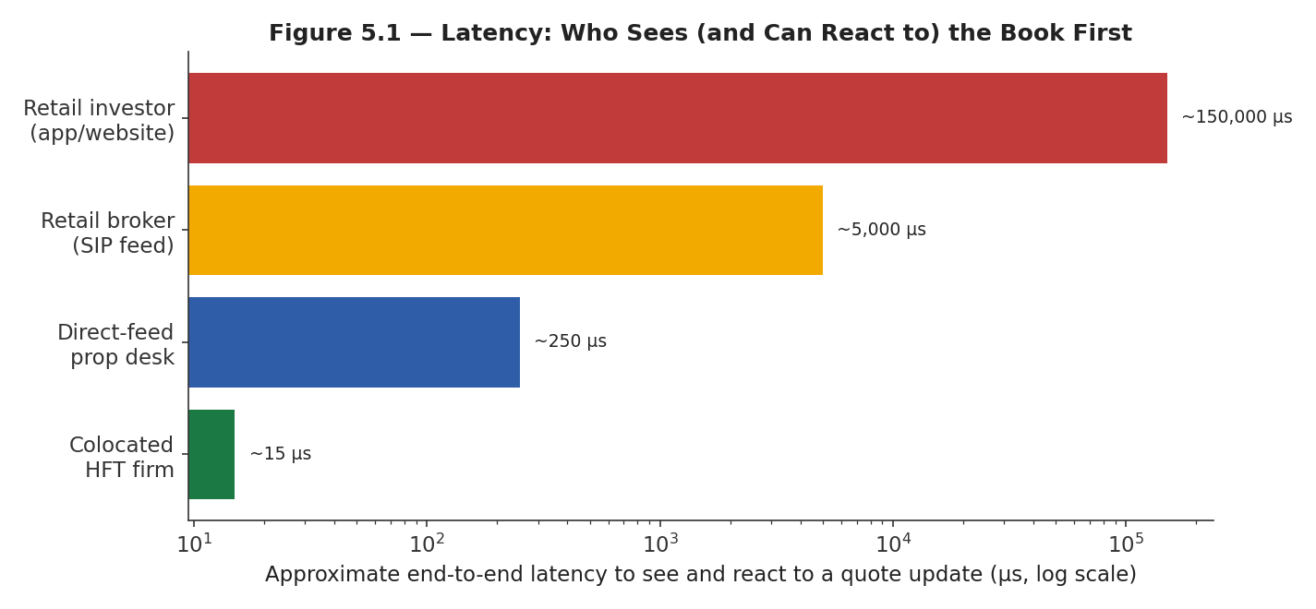
Figure 5.1 — Illustrative end-to-end latency to observe and react to a quote update, across a range of market participants. Note the axis is logarithmic — the gap between a colocated firm and a retail app is a factor of roughly ten thousand, not ten.
This is the mechanical link between latency and adverse selection (Section 3.3): a slow participant's resting limit order is, by construction, more likely to still be sitting in the book — unable to cancel in time — exactly when fast-reacting, informed participants trade against it after news arrives. Latency does not need to be measured in microseconds to matter at your own level of trading; even the multi-second delay of a retail brokerage app relative to a professional data feed is enough to matter for any strategy that competes on speed rather than on a genuinely longer-horizon information edge.
Prerequisite gate — Awareness of latency is enough to understand why 'my backtest fill price equals the price I observed when the bar closed' is an unrealistic assumption for any short-horizon strategy — by the time you can act on an observed price, that price may already be stale. Actually competing on latency is a systems-engineering discipline in its own right, and is out of scope until Depth 3+.

Practical Exercise
Reconstruct a limit order book from a stream of order-book update messages, and compute the bid-ask spread and depth-weighted mid-price at each timestamp.

Suggested approach
- Model the book as two sorted price → size maps, one per side (a heap or sorted dictionary works well).
- Process each update message (new order, cancel, or trade) in timestamp order, mutating the relevant side.
- After each update, recompute best bid, best ask, quoted spread, and a depth-weighted mid-price — a mid-price that weights the best bid and ask by the size resting behind each, so a lopsided book (e.g., 9,000 on the bid vs. 500 on the ask) pulls the weighted mid toward the thicker side.
- Validate against a few hand-checked timestamps before running it over a full day of messages.
Depth-weighted mid = (Best Bid × Ask size + Best Ask × Bid size) / (Bid size + Ask size)
# Skeleton for the practical exercise
bids = {} # price -> size
asks = {} # price -> size

def apply_update(msg):
book = bids if msg['side'] == 'bid' else asks
if msg['type'] == 'new':
book[msg['price']] = book.get(msg['price'], 0) + msg['size']
elif msg['type'] == 'cancel':
book[msg['price']] -= msg['size']
elif msg['type'] == 'trade':
book[msg['price']] -= msg['size']

def best_bid(): return max(p for p, s in bids.items() if s > 0)
def best_ask(): return min(p for p, s in asks.items() if s > 0)

def depth_weighted_mid():
bb, ba = best_bid(), best_ask()
bsz, asz = bids[bb], asks[ba]
return (bb * asz + ba * bsz) / (bsz + asz)

Common Beginner Mistakes
- Backtesting only against closing prices with no slippage or spread cost assumption — treating the printed close as a price at which unlimited size could actually have transacted.
- Assuming infinite liquidity at the quoted price for any order size — ignoring that depth beyond the touch is finite and that larger orders walk the book.
- Treating the bid-ask spread as a fixed constant rather than something that widens mechanically around news, at the open/close, and in thin names.
- Confusing a marketable limit order with a plain limit order, and assuming both have the same fill probability and price risk.
- Ignoring tick size when comparing spreads or liquidity across instruments with different minimum price increments.

Advanced Extensions
The following are Depth 3+ topics, introduced here only by name so you know what to look for when you reach them:
- Full market-impact modelling — calibrated square-root and other impact models, temporary vs. permanent impact, and optimal execution (Almgren-Chriss and successors).
- Queue-position modelling — estimating fill probability and expected queue position analytically or via simulation, central to passive market-making strategy design.
- Adverse-selection modelling — quantitative Glosten-Milgrom and Kyle-model treatments of informed trading, and how a market maker should optimally skew quotes in response.

Professional Applications
- Realistic backtesting — incorporating spread, depth-aware market impact, and latency assumptions so that simulated P&L reflects what could actually have been achieved.
- Execution algorithm design — VWAP, TWAP, implementation-shortfall, and liquidity-seeking algorithms all exist specifically to manage the market-impact and adverse-selection trade-offs covered in Parts 3 and 4.
- Market-making strategy design — quoting both sides of the book profitably requires managing queue position, inventory risk, and adverse selection simultaneously; every concept in this module is a direct input.

Where to Go Next
This module deliberately stopped at awareness-level for queue position, order-book imbalance, adverse selection, and latency. Depth 3+ of this same module returns to each of them quantitatively — with explicit models, calibration procedures, and simulation exercises — and is the appropriate next stop before attempting to design or operate any market-making or high-frequency strategy, per the prerequisite gate at the start of this guide. From there, the curriculum's Execution Algorithms and Risk Metrics modules build directly on this foundation.

